Grid Layout
Grid Layout is a new layout model for CSS that has powerful abilities to control the sizing and positioning of boxes and their contents.
Unlike Flexible Box Layout, which is single-axis–oriented, Grid Layout is optimized for 2-dimensional layouts: those in which alignment of content is desired in both dimensions.

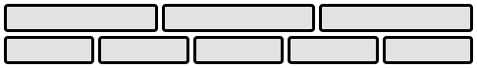
Representative Flex Layout Example

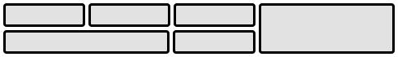
Representative Grid Layout Example

Grid Layout controls the layout of its content through the use of a grid: an intersecting set of horizontal and vertical lines which create a sizing and positioning coordinate system for the grid container’s contents.

Grid Layout features

-fixed, flexible, and content-based track sizing functions
-explicit item placement via forwards (positive) and backwards (negative) numerical grid coordinates, named grid lines, and named grid areas; automatic item placement into empty areas,
including reordering with order
-space-sensitive track repetition and automatic addition of rows or columns to accommodate additional content
-control over alignment and spacing with margins, gutters, and the alignment properties
-the ability to overlap content and control layering with z-index

Grid containers can be nested or mixed with flex containers as necessary to create more complex layouts.
The tracks (rows and columns) of the grid are declared and sized either explicitly through the explicit grid properties or are implicitly created when items are placed outside the explicit grid. The grid shorthand and its sub-properties define the parameters of the grid.

Grid Layout Concepts and Terminology
In grid layout, the content of a grid container is laid out by positioning and aligning it into a grid. The grid is an intersecting set of horizontal and vertical grid lines that divides the grid container’s space into grid areas, into which grid items (representing the grid container’s content) can be placed. There are two sets of grid lines: one set defining columns that run along the block axis, and an orthogonal set defining rows along the inline axis.

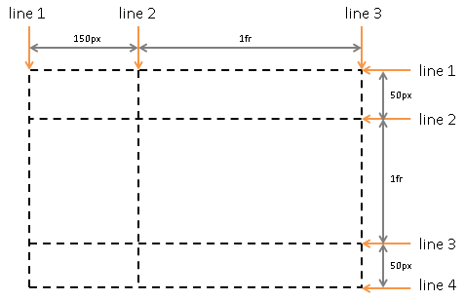
Grid lines: Three in the block axis and four in the inline axis.

Grid Lines
Grid lines are the horizontal and vertical dividing lines of the grid. A grid line exists on either side of a column or row. They can be referred to by numerical index, or by an author-specified name. A grid item references the grid lines to determine its position within the grid using the grid-placement properties..

This first example demonstrates how an author would position a grid item using grid line numbers:
#grid {
display: grid;
grid-template-columns: 150px 1fr;
grid-template-rows: 50px 1fr 50px;}

#item1 { grid-column: 2;
grid-row-start: 1; grid-row-end: 4; }

This second example uses explicitly named grid lines:
#grid {
display: grid;
grid-template-columns: 150px [item1-start] 1fr [item1-end];
grid-template-rows: [item1-start] 50px 1fr 50px [item1-end];}

#item1 {
grid-column: item1-start / item1-end;
grid-row: item1-start / item1-end;}

Grid Tracks and Cells
Grid track is a generic term for a grid column or grid row—in other words, it is the space between two adjacent grid lines. Each grid track is assigned a sizing function, which controls how wide or tall the column or row may grow, and thus how far apart its bounding grid lines are. Adjacent grid tracks can be separated by gutters but are otherwise packed tightly.

A grid cell is the intersection of a grid row and a grid column. It is the smallest unit of the grid that can be referenced when positioning grid items.

In the following example there are two columns and three rows. The first column is fixed at 150px. The second column uses flexible sizing, which is a function of the unassigned space in the grid, and thus will vary as the width of the grid container changes. If the used width of the grid container is 200px, then the second column is 50px wide. If the used width of the grid container is 100px, then the second column is 0px and any content positioned in the column will overflow the grid container.
#grid {
display: grid;
grid-template-columns: 150px 1fr; /* two columns */
grid-template-rows: 50px 1fr 50px; /* three rows */
}

Grid Areas
A grid area is the logical space used to lay out one or more grid items. A grid area consists of one or more adjacent grid cells. It is bound by four grid lines, one on each side of the grid area, and participates in the sizing of the grid tracks it intersects. A grid area can be named explicitly using the grid-template-areas property of the grid container, or referenced implicitly by its bounding grid lines. A grid item is assigned to a grid area using the grid-placement properties.
/* using the template syntax */
#grid {
display: grid;
grid-template-areas: ". a"
"b a"
". a";
grid-template-columns: 150px 1fr;
grid-template-rows: 50px 1fr 50px;
}
#item1 { grid-area: a }
#item2 { grid-area: b }
#item3 { grid-area: b }
/* Align items 2 and 3 at different points in the grid area "b". */
/* By default, grid items are stretched to fit their grid area */
/* and these items would layer one over the other. */
#item2 { align-self: start; }
#item3 { justify-self: end; align-self: end; }
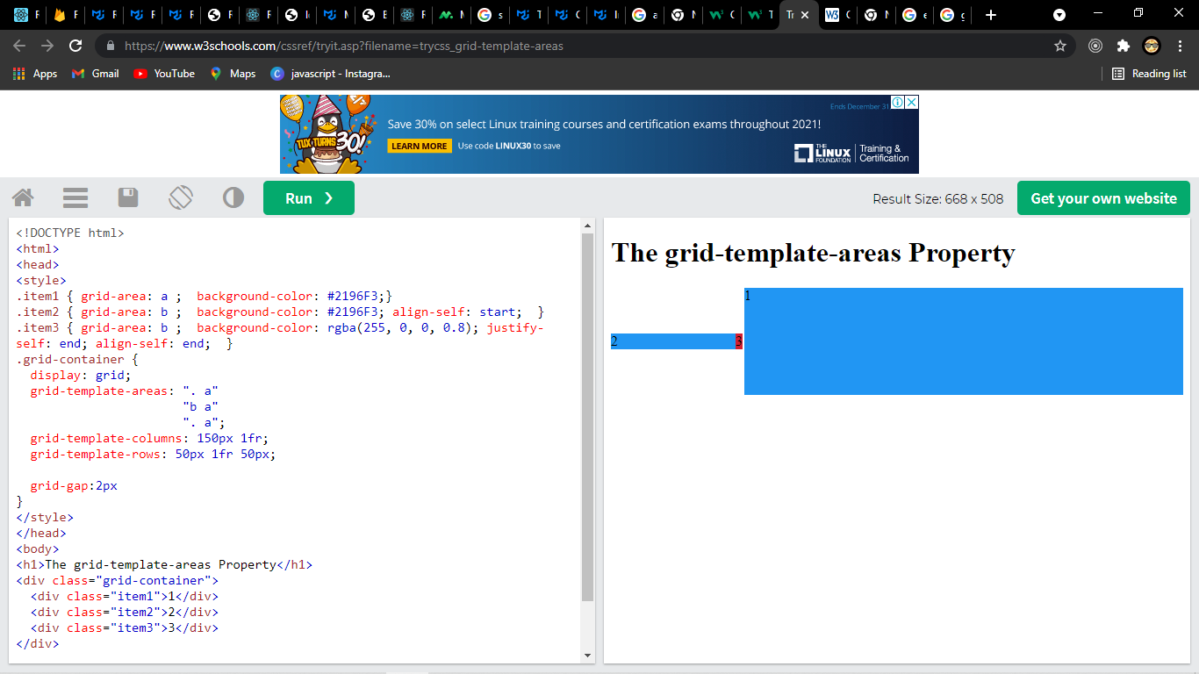
A grid item’s grid area forms the containing block into which it is laid out. Grid items placed into the same grid area do not directly affect each other’s layout. Indirectly, however, a grid item occupying a grid track with an intrinsic sizing function (An intrinsic sizing function (min-content, max-content, auto, fit-content())) can affect the size of that track (and thus the positions of its bounding grid lines), which in turn can affect the position or size of another grid item.

Reordering and Accessibility
Grid layout gives authors great powers of rearrangement over the document. However, these are not a substitute for correct ordering of the document source. The order property and grid placement do not affect ordering in non-visual media (such as speech)

Many web pages have a similar shape in the markup, with a header on top, a footer on bottom, and then a content area and one or two additional columns in the middle. Generally, it’s desirable that the content come first in the page’s source code, before the additional columns. However, this makes many common designs, such as simply having the additional columns on the left and the content area on the right, difficult to achieve. This has been addressed in many ways over the years, often going by the name "Holy Grail Layout" when there are two additional columns.
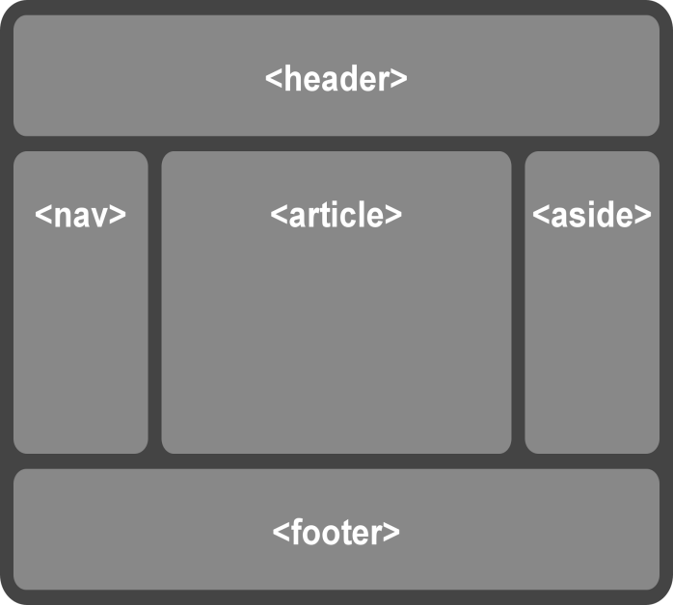

This layout can be easily achieved with grid layout:
body { display: grid;
grid: "h h h"
"a b c"
"f f f";
grid-template-columns: auto 1fr 20%; }
article { grid-area: b; min-width: 12em; }
nav { grid-area: a; /* auto min-width */ }
aside { grid-area: c; min-width: 12em; }
In order to preserve the author’s intended ordering in all presentation modes, authoring tools—including WYSIWYG editors as well as Web-based authoring aids—must reorder the underlying document source and not use order or grid-placement properties to perform reordering unless the author has explicitly indicated that the underlying document order (which determines speech and navigation order) should be out-of-sync with the visual order.

Grid Containers

Establishing Grid Containers: the grid and inline-grid display values

grid
This value causes an element to generate a grid container box that is block-level when placed in flow layout.

inline-grid
This value causes an element to generate an grid container box that is inline-level when placed in flow layout.

A grid container establishes an independent grid formatting context for its contents. This is the same as establishing an independent block formatting context, except that grid layout is used instead of block layout: floats do not intrude into the grid container, and the grid container’s margins do not collapse with the margins of its contents. The contents of a grid container are laid out into a grid, with grid lines forming the boundaries of each grid items’ containing block.

Grid Items
Loosely speaking, the grid items of a grid container are boxes representing its in-flow contents.

Each in-flow child of a grid container becomes a grid item, and each contiguous sequence of child text runs is wrapped in an anonymous block container grid item.
However, if the entire sequence of child text runs contains only white space (i.e. characters that can be affected by the white-space property) it is instead not rendered (just as if its text nodes were display:none).

<div style="display: grid">

<!-- grid item: block child -->
<div id="item1">block</div>

<!-- grid item: floated element; floating is ignored -->
<div id="item2" style="float: left;">float</div>

<!-- grid item: anonymous block box around inline content -->
anonymous item 3

<!-- grid item: inline child -->
<span>
item 4
<!-- grid items do not split around blocks -->
<q style="display: block" id=not-an-item>item 4</q>
item 4
</span></div>
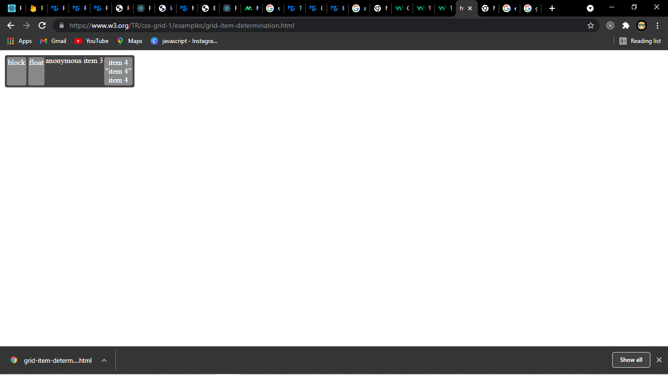

Grid Item Sizing
A grid item is sized within the containing block defined by its grid area.

Grid item calculations for automatic sizes in a given dimensions vary by their self-alignment values:

normal
If the grid item is a replaced element with a natural size in the relevant dimension (or with a preferred aspect ratio and a size in the other dimension) the grid item is sized as for align-self: start
Otherwise, if the grid item has a preferred aspect ratio, the grid item is sized as for a block-level box.
Otherwise, the grid item is sized as for stretch.

stretch
Use the inline size calculation rules for non-replaced boxes

Note: This can distort the aspect ratio of an item with a preferred aspect ratio, if its size is also constrained in the other axis.

all other values
Size the item as fit-content.

The following informative table summarizes the automatic sizing of grid items:
Summary of automatic sizing behavior of grid items
Alignment | Non-replaced Element Size | Replaced Element Size
normal | Fill grid area | Use natural size
stretch | Fill grid area | Fill grid area
start/center/etc. | fit-content sizing (like floats) | Use natural size

Reordered Grid Items: the order property
The order property also applies to grid items. It affects their auto-placement and painting order.

As with reordering flex items, the order property must only be used when the visual order needs to be out-of-sync with the speech and navigation order; otherwise the underlying document source should be reordered instead.

Grid Item Margins and Paddings
As adjacent grid items are independently contained within the containing block formed by their grid areas, the margins of adjacent grid items do not collapse.

Percentage margins and paddings on grid items, like those on block boxes, are resolved against the inline size of their containing block, e.g. left/right/top/bottom percentages all resolve against their containing block’s width in horizontal writing modes.

Auto margins expand to absorb extra space in the corresponding dimension, and can therefore be used for alignment.

Z-axis Ordering: the z-index property
Grid items can overlap when they are positioned into intersecting grid areas, or even when positioned in non-intersecting areas because of negative margins or positioning. The painting order of grid items is exactly the same as inline blocks
except that order-modified document order( starting from the lowest numbered ordinal group and going up ))) is used in place of raw document order and z-index values other than auto create a stacking context even if position is static (behaving exactly as if position were relative). Thus the z-index property can easily be used to control the z-axis order of grid items.
Descendants that are positioned outside a grid item still participate in any stacking context established by the grid item.

The following diagram shows several overlapping grid items, with a combination of implicit source order and explicit z-index used to control their stacking order.
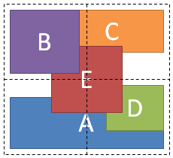
<style type="text/css">
#grid {
display: grid;
grid-template-columns: 1fr 1fr;
grid-template-rows: 1fr 1fr
}
#A { grid-column: 1 / span 2; grid-row: 2; align-self: end; }
#B { grid-column: 1; grid-row: 1; z-index: 10; }
#C { grid-column: 2; grid-row: 1; align-self: start; margin-left: -20px; }
#D { grid-column: 2; grid-row: 2; justify-self: end; align-self: start; }
#E { grid-column: 1 / span 2; grid-row: 1 / span 2;
z-index: 5; justify-self: center; align-self: center; }
</style>
<div id="grid">
<div id="A">A</div>
<div id="B">B</div>
<div id="C">C</div>
<div id="D">D</div>
<div id="E">E</div>
</div>
Automatic Minimum Size of Grid Items
Note: Much of the sizing terminology used in this section (and throughout the rest of the specification) is defined in CSS Intrinsic and Extrinsic Sizing.

To provide a more reasonable default minimum size for grid items, the used value of its automatic minimum size in a given axis is the content-based minimum size if all of the following are true:

it is not a scroll container

it spans at least one track in that axis whose min track sizing function is auto

if it spans more than one track in that axis, none of those tracks are flexible

Otherwise, the automatic minimum size is zero, as usual.

The content-based minimum size for a grid item in a given dimension is its specified size suggestion if it exists, otherwise its transferred size suggestion if that exists, else its content size suggestion,

The content size suggestion, specified size suggestion, and transferred size suggestion used in this calculation account for the relevant min/max/preferred size properties so that the content-based minimum size does not interfere with any author-provided constraints,

specified size suggestion
If the item’s preferred size in the relevant axis is definite, then the specified size suggestion is that size. It is otherwise undefined.

transferred size suggestion
If the item has a preferred aspect ratio and its preferred size in the opposite axis is definite, then the transferred size suggestion is that size (clamped by the opposite-axis minimum and maximum sizes if they are definite), converted through the aspect ratio. It is otherwise undefined.

content size suggestion
The content size suggestion is the min-content size in the relevant axis, clamped, if it has a preferred aspect ratio, by any definite opposite-axis minimum and maximum sizes converted through the aspect ratio.

Defining the Grid

The Explicit Grid

The three properties grid-template-rows, grid-template-columns, and grid-template-areas together define the explicit grid of a grid container by specifying its explicit grid tracks.
The final grid may end up larger due to grid items placed outside the explicit grid; in this case implicit tracks will be created,
these implicit tracks will be sized by the grid-auto-rows and grid-auto-columns properties.

The size of the explicit grid is determined by the larger of the number of rows/columns defined by grid-template-areas and the number of rows/columns sized by grid-template-rows/grid-template-columns.
Any rows/columns defined by grid-template-areas but not sized by grid-template-rows/grid-template-columns take their size from the grid-auto-rows/grid-auto-columns properties.
If these properties don’t define any explicit tracks the explicit grid still contains one grid line in each axis.

Numeric indexes in the grid-placement properties count from the edges of the explicit grid.
Positive indexes count from the start side (starting from 1 for the start-most explicit line),
while negative indexes count from the end side (starting from -1 for the end-most explicit line).

The grid and grid-template properties are shorthands that can be used to set all three explicit grid properties (grid-template-rows, grid-template-columns, and grid-template-areas) at the same time.
The grid shorthand also resets properties controlling the implicit grid, whereas the grid-template property leaves them unchanged.

Explicit Track Sizing: the grid-template-rows and grid-template-columns properties
Name: | grid-template-columns, grid-template-rows
Value: | none | <track-list> | <auto-track-list>
Initial: | none
Applies to: | grid containers
Inherited: | no
Percentages: | refer to corresponding dimension of the content area
Computed value: | the keyword none or a computed track list
Canonical order: | per grammar
Animation type: | if the list lengths match, by computed value type per item in the computed track list ; discrete otherwise

These properties specify, as a space-separated track list, the line names and track sizing functions of the grid.
The grid-template-columns property specifies the track list for the grid’s columns,
while grid-template-rows specifies the track list for the grid’s rows.

Values have the following meanings:

none
Indicates that no explicit grid tracks are created by this property (though explicit grid tracks could still be created by grid-template-areas).
Note: In the absence of an explicit grid any rows/columns will be implicitly generated, and their size will be determined by the grid-auto-rows and grid-auto-columns properties.

<track-list> | <auto-track-list>
Specifies the track list as a series of track sizing functions and line names. Each track sizing function can be specified as a length, a percentage of the grid container’s size, a measurement of the contents occupying the column or row, or a fraction of the free space in the grid. It can also be specified as a range using the minmax() notation, which can combine any of the previously mentioned mechanisms to specify separate min and max track sizing functions for the column or row.

The syntax of a track list is:

Formal Syntax

<track-list> = [ <line-names>? [ <track-size> | <track-repeat> ] ]+ <line-names>?
<auto-track-list> = [ <line-names>? [ <fixed-size> | <fixed-repeat> ] ]* <line-names>? <auto-repeat>
[ <line-names>? [ <fixed-size> | <fixed-repeat> ] ]* <line-names>?
<explicit-track-list> = [ <line-names>? <track-size> ]+ <line-names>?

<track-size> = <track-breadth> | minmax( <inflexible-breadth> , <track-breadth> ) | fit-content( <length-percentage> )
<fixed-size> = <fixed-breadth> | minmax( <fixed-breadth> , <track-breadth> ) | minmax( <inflexible-breadth> , <fixed-breadth> )
<track-breadth> = <length-percentage> | <flex> | min-content | max-content | auto
<inflexible-breadth> = <length-percentage> | min-content | max-content | auto
<fixed-breadth> = <length-percentage>
<line-names> = '[' <custom-ident>* ']'
.

Example: syntax

/* Keyword value */
grid-template-columns: none;

/* <track-list> values */
grid-template-columns: 100px 1fr;
grid-template-columns: [linename] 100px;
grid-template-columns: [linename1] 100px [linename2 linename3];
grid-template-columns:minmax(100px, 1fr);
grid-template-columns: fit-content(40%);
grid-template-columns:repeat(3, 200px);
grid-template-columns:subgrid;
grid-template-columns: masonry;

/* <auto-track-list> values */
grid-template-columns:200px repeat(auto-fill, 100px) 300px;
grid-template-columns: minmax(100px, max-content)
repeat(auto-fill, 200px) 20%;
grid-template-columns:: [linename1] 100px [linename2]
repeat(auto-fit, [linename3 linename4] 300px)
100px;
grid-template-columns: [linename1 linename2] 100px
repeat(auto-fit, [linename1] 300px) [linename3];

/* Global values */
grid-template-columns: inherit;
grid-template-columns: initial;
grid-template-columns: revert;
grid-template-columns: unset;

Values

none
Indicates that there is no explicit grid. Any columns will be implicitly generated and their size will be determined by the grid-auto-columns property.

[linename]
A <custom-ident> specifying a name for the line in that location. The ident may be any valid string other than the reserved words span and auto. Lines may have multiple names separated by a space inside the square brackets, for example [line-name-a line-name-b].

<length>
A non-negative length, giving the width of the column.

<percentage>
Is a non-negative <percentage> value relative to the inline size of the grid container. If the size of the grid container depends on the size of its tracks, then the percentage must be treated as auto.
The intrinsic size contributions of the track may be adjusted to the size of the grid container and increase the final size of the track by the minimum amount that would result in honoring the percentage.

<flex>
Is a non-negative dimension with the unit fr specifying the track’s flex factor. Each <flex>-sized track takes a share of the remaining space in proportion to its flex factor.

When appearing outside a minmax() notation, it implies an automatic minimum (i.e. minmax(auto, <flex>)).

max-content
Is a keyword representing the largest maximal content contribution of the grid items occupying the grid track.

min-content
Is a keyword representing the largest minimal content contribution of the grid items occupying the grid track.

minmax(min, max)
Is a functional notation that defines a size range greater than or equal to min and less than or equal to max. If max is smaller than min, then max is ignored and the function is treated as min. As a maximum, a <flex> value sets the track’s flex factor. It is invalid as a minimum.

auto
As a maximum represents the largest max-content size of the items in that track.

As a minimum represents the largest minimum size of items in that track (specified by the min-width/min-height of the items). This is often, though not always, the min-content size.

If used outside of minmax() notation, auto represents the range between the minimum and maximum described above. This behaves similarly to minmax(min-content,max-content) in most cases.

Note: auto track sizes (and only auto track sizes) can be stretched by the align-content and justify-content properties. Therefore by default, an auto sized track will take up any remaining space in the grid container.

fit-content( [ <length> | <percentage> ] )
Represents the formula min(max-content, max(auto, argument)), which is calculated similar to auto (i.e. minmax(auto, max-content)), except that the track size is clamped at argument if it is greater than the auto minimum.

repeat( [ <positive-integer> | auto-fill | auto-fit ] , <track-list> )
Represents a repeated fragment of the track list, allowing a large number of columns that exhibit a recurring pattern to be written in a more compact form.

masonry
The masonry value indicates that this axis should be laid out according to the masonry algorithm.

subgrid
The subgrid value indicates that the grid will adopt the spanned portion of its parent grid in that axis. Rather than being specified explicitly, the sizes of the grid rows/columns will be taken from the parent grid’s definition.

Formal Syntax

<track-list> = [ <line-names>? [ <track-size> | <track-repeat> ] ]+ <line-names>?
<auto-track-list> = [ <line-names>? [ <fixed-size> | <fixed-repeat> ] ]* <line-names>? <auto-repeat>
[ <line-names>? [ <fixed-size> | <fixed-repeat> ] ]* <line-names>?
<explicit-track-list> = [ <line-names>? <track-size> ]+ <line-names>?

<track-size> = <track-breadth> | minmax( <inflexible-breadth> , <track-breadth> ) | fit-content( <length-percentage> )
<fixed-size> = <fixed-breadth> | minmax( <fixed-breadth> , <track-breadth> ) | minmax( <inflexible-breadth> , <fixed-breadth> )
<track-breadth> = <length-percentage> | <flex> | min-content | max-content | auto
<inflexible-breadth> = <length-percentage> | min-content | max-content | auto
<fixed-breadth> = <length-percentage>
<line-names> = '[' <custom-ident>* ']'

Naming Grid Lines: the [<custom-ident>*] syntax
While grid lines can always be referred to by their numerical index, line names can make the grid-placement properties easier to understand and maintain. Line names can be explicitly assigned with the grid-template-rows and grid-template-columns properties, or implicitly assigned by named grid areas with the grid-template-areas property.

For example, the following code gives meaningful names to all of the lines in the grid. Note that some of the lines have multiple names.
#grid {
display: grid;
grid-template-columns: [first nav-start] 150px [main-start] 1fr [last];
grid-template-rows: [first header-start] 50px [main-start] 1fr [footer-start] 50px [last];
}

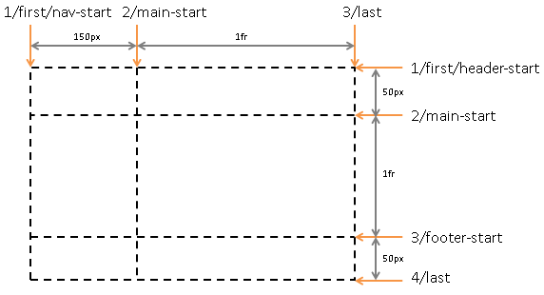

Repeating Rows and Columns: the repeat() notation
The repeat() notation represents a repeated fragment of the track list, allowing a large number of columns or rows that exhibit a recurring pattern to be written in a more compact form.

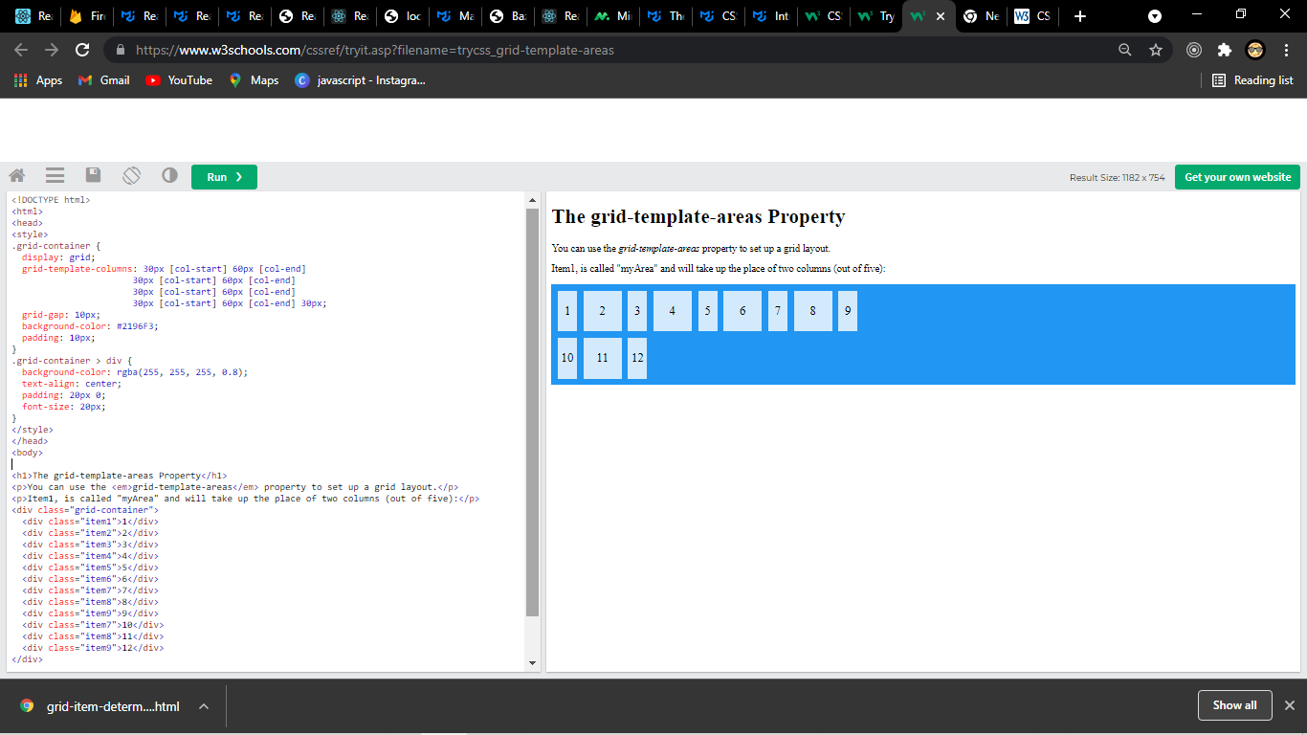
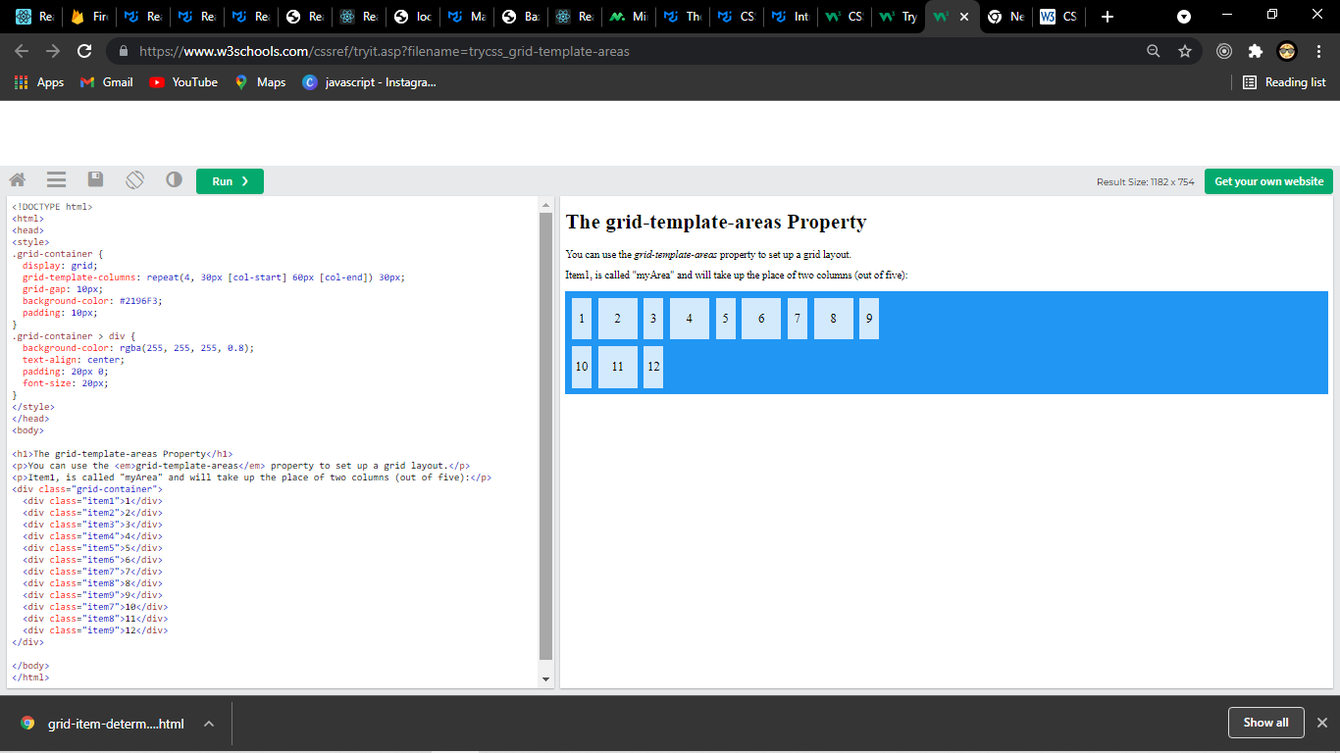
.
The generic form of the repeat() syntax is, approximately,

repeat( [ <integer [1,∞]> | auto-fill | auto-fit ] , <track-list> )

The first argument specifies the number of repetitions. The second argument is a track list, which is repeated that number of times. However, there are some restrictions:
The repeat() notation can’t be nested.
Automatic repetitions (auto-fill or auto-fit) cannot be combined with intrinsic or flexible sizes.

Thus the precise syntax of the repeat() notation has several forms:

<track-repeat> = repeat( [ <integer [1,∞]> ] , [ <line-names>? <track-size> ]+ <line-names>? )
<auto-repeat> = repeat( [ auto-fill | auto-fit ] , [ <line-names>? <fixed-size> ]+ <line-names>? )
<fixed-repeat> = repeat( [ <integer [1,∞]> ] , [ <line-names>? <fixed-size> ]+ <line-names>? )

The <track-repeat> variant can represent the repetition of any <track-size>, but is limited to a fixed number of repetitions.
The <auto-repeat> variant can repeat automatically to fill a space, but requires definite track sizes so that the number of repetitions can be calculated. It can only appear once in the track list, but the same track list can also contain <fixed-repeat>s.

If a repeat() function ends up placing two <line-names> adjacent to each other, the name lists are merged. For example, repeat(2, [a] 1fr [b]) is equivalent to [a] 1fr [b a] 1fr [b].

Automatic repetition of tracks
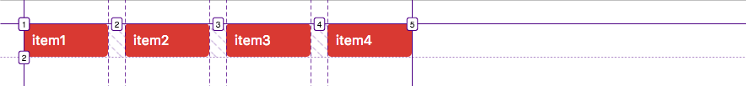
An explicit grid with 4 vertical tracks each 100px wide, generated by the repeat notation.
The repeat notation is quite useful, but it can be automated even further. Instead of setting a fixed number of repetitions we can use the auto-fill and auto-fit keywords.

Auto-filling tracks
The auto-fill keyword creates as many tracks as fit into the grid container without causing the grid to overflow it.
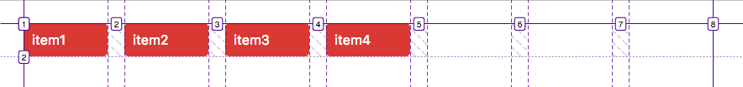
Repetition of as many vertical tracks with a width of 100px as fit into the grid container.
.grid {
display: grid;
grid-template-columns: repeat(auto-fill, 100px);
grid-gap: 20px;

Auto-fitting tracks

The auto-fit keyword behaves the same way as auto-fill, except that after grid item placement it will only create as many tracks as needed and any empty repeated track collapses.
.grid {
display: grid;
grid-template-columns: repeat(auto-fit, 100px);
grid-gap: 20px;}
In the example used in this section the grid will look the same with repeat(auto-fit, 100px); and repeat(4, 100px);. The difference is visible when there are more than 4 grid items.
If there are more items, auto-fit creates more columns.
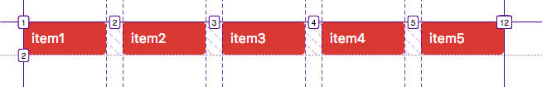
The repeat notation with the auto-fit keyword creates as many tracks as needed and as many as fit into the grid container. }

Flexible Lengths: the fr unit
A flexible length or <flex> is a dimension with the fr unit, which represents a fraction of the leftover space in the grid container. Tracks sized with fr units are called flexible tracks as they flex in response to leftover space similar to how flex items with a zero base size fill space in a flex container.

The distribution of leftover space occurs after all non-flexible track sizing functions have reached their maximum. The total size of such rows or columns is subtracted from the available space, yielding the leftover space, which is then divided among the flex-sized rows and columns in proportion to their flex factor.

Each column or row’s share of the leftover space can be computed as the column or row’s <flex> * <leftover space> / <sum of all flex factors>.
<flex> values between 0fr and 1fr have a somewhat special behavior: when the sum of the flex factors is less than 1, they will take up less than 100% of the leftover space.

When the available space is infinite (which happens when the grid container’s width or height is indefinite), flex-sized grid tracks are sized to their contents while retaining their respective proportions.
.

Named Areas: the grid-template-areas property
Name: | grid-template-areas
Value: | none | <string>+
Initial: | none
Applies to: | grid containers
Inherited: | no
Percentages: | n/a
Computed value: | the keyword none or a list of string values
Canonical order: | per grammar
Animation type: | discrete

This property specifies named grid areas, which are not associated with any particular grid item, but can be referenced from the grid-placement properties. The syntax of the grid-template-areas property also provides a visualization of the structure of the grid, making the overall layout of the grid container easier to understand.

none
Indicates that no named grid areas, and likewise no explicit grid tracks, are defined by this property (though explicit grid tracks could still be created by grid-template-columns or grid-template-rows).
Note: In the absence of an explicit grid any rows/columns will be implicitly generated, and their size will be determined by the grid-auto-rows and grid-auto-columns properties.

<string>
A row is created for every separate string listed for the grid-template-areas property, and a column is created for each cell in the string, when parsed as follows:
Tokenize the string into a list of the following tokens, using longest-match semantics:

A sequence of name code points, representing a named cell token with a name consisting of its code points.
A sequence of one or more "." (U+002E FULL STOP), representing a null cell token.
A sequence of whitespace, representing nothing (do not produce a token).
A sequence of any other characters, representing a trash token.
Note: These rules can produce cell names that do not match the <ident> syntax, such as "1st 2nd 3rd", which requires escaping when referencing those areas by name in other properties, like grid-row: \31st; to reference the area named 1st.
A null cell token represents an unnamed area in the grid container.
A named cell token creates a named grid area with the same name. Multiple named cell tokens within and between rows create a single named grid area that spans the corresponding grid cells.
A trash token is a syntax error, and makes the declaration invalid.
All strings must define the same number of cell tokens (named cell tokens and/or null cell tokens), and at least one cell token, or else the declaration is invalid. If a named grid area spans multiple grid cells, but those cells do not form a single filled-in rectangle, the declaration is invalid.

Note: Non-rectangular or disconnected regions may be permitted in a future version of this module.

In this example, the grid-template-areas property is used to create a page layout where areas are defined for header content (head), navigational content (nav), footer content (foot), and main content (main). Accordingly, the template creates three rows and two columns, with four named grid areas. The head area spans both columns and the first row of the grid.
#grid {
display: grid;
grid-template-areas: "head head"
"nav main"
"foot ...."
}
#grid > header { grid-area: head; }
#grid > nav { grid-area: nav; }
#grid > main { grid-area: main; }
#grid > footer { grid-area: foot; }

Explicit Grid Shorthand: the grid-template property

Name: | grid-template
Value: | none | [ <'grid-template-rows'> / <'grid-template-columns'> ] | [ <line-names>? <string> <track-size>? <line-names>? ]+ [ / <explicit-track-list> ]?
Initial: | none
Applies to: | grid containers
Inherited: | see individual properties
Percentages: | see individual properties
Computed value: | see individual properties
Animation type: | see individual properties
Canonical order: | per grammar

.

The grid-template property is a shorthand for setting grid-template-columns, grid-template-rows, and grid-template-areas in a single declaration.

none
Sets grid-template-rows and grid-template-columns to the specified values, respectively, and sets grid-template-areas to none.
grid-template: auto 1fr / auto 1fr auto;
is equivalent to
grid-template-rows: auto 1fr;
grid-template-columns: auto 1fr auto;
grid-template-areas: none;

[ <line-names>? <string> <track-size>? <line-names>? ]+ [ / <explicit-track-list> ]?
Sets grid-template-areas to the strings listed.
Sets grid-template-rows to the <track-size>s following each string (filling in auto for any missing sizes), and splicing in the named lines defined before/after each size.
Sets grid-template-columns to the track listing specified after the slash (or none, if not specified).

This syntax allows the author to align track names and sizes inline with their respective grid areas.
grid-template: [header-top] "a a a" [header-bottom]
[main-top] "b b b" 1fr [main-bottom]
/ auto 1fr auto;
is equivalent to
grid-template-areas: "a a a"
"b b b";
grid-template-rows: [header-top] auto [header-bottom main-top] 1fr [main-bottom];
grid-template-columns: auto 1fr auto;
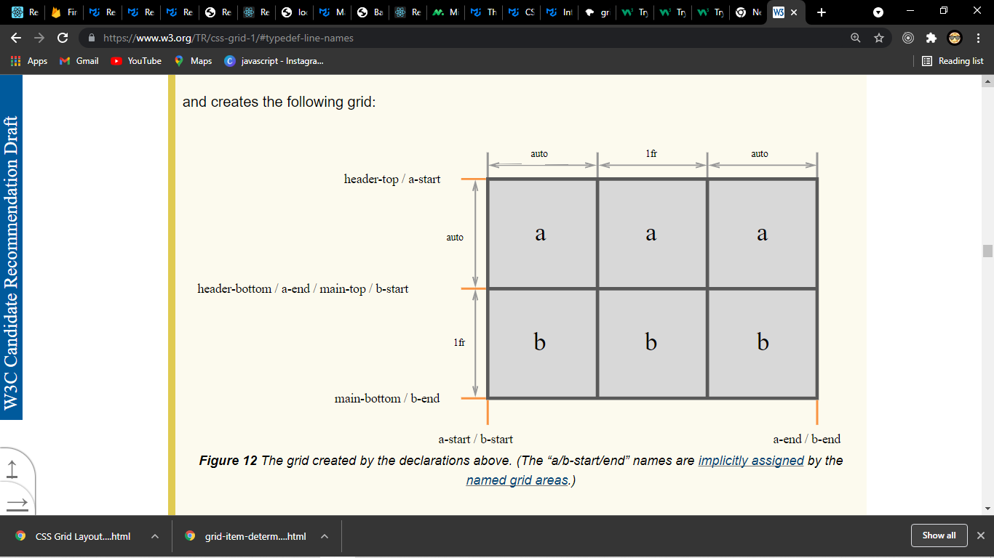

Implicit Grids
If there are more grid items than cells in the grid or when a grid item is placed outside of the explicit grid, the grid container automatically generates grid tracks by adding grid lines to the grid. The explicit grid together with these additional implicit tracks and lines forms the so called implicit grid.

Sizing implicit tracks
The grid-auto-rows and grid-auto-columns properties give us control over the size of implicit tracks.

.grid {
display: grid;
grid-template-columns: repeat(4, 1fr);
grid-template-rows: 100px 100px;
grid-gap: 20px;
grid-auto-columns: 200px;
grid-auto-rows: 60px;
}
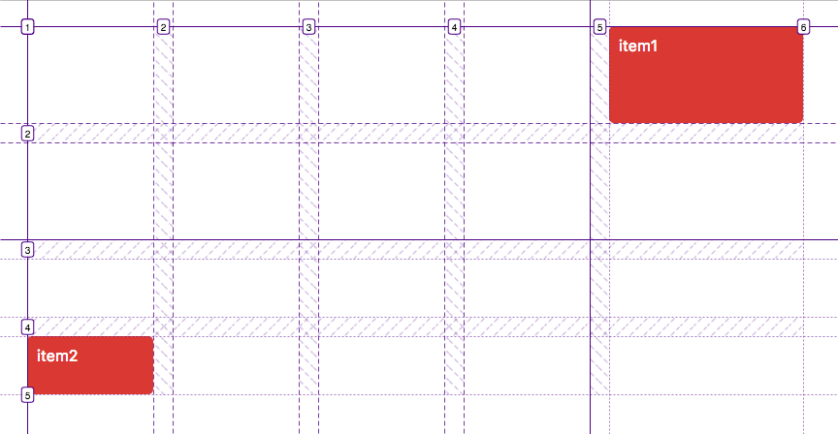

Automatic Placement: the grid-auto-flow property

Name: | grid-auto-flow
Value: | [ row | column ] || dense
Initial: | row
Applies to: | grid containers
Inherited: | no
Percentages: | n/a
Computed value: | specified keyword(s)
Canonical order: | per grammar
Animation type: | discrete
Grid items that aren’t explicitly placed are automatically placed into an unoccupied space in the grid container by the auto-placement algorithm.
grid-auto-flow controls how the auto-placement algorithm works, specifying exactly how auto-placed items get flowed into the grid.

row
The auto-placement algorithm places items by filling each row in turn, adding new rows as necessary. If neither row nor column is provided, row is assumed.
column
The auto-placement algorithm places items by filling each column in turn, adding new columns as necessary.
dense
If specified, the auto-placement algorithm uses a “dense” packing algorithm, which attempts to fill in holes earlier in the grid if smaller items come up later. This may cause items to appear out-of-order, when doing so would fill in holes left by larger items.
If omitted, a “sparse” algorithm is used, where the placement algorithm only ever moves “forward” in the grid when placing items, never backtracking to fill holes. This ensures that all of the auto-placed items appear “in order”, even if this leaves holes that could have been filled by later items.

In the following example, there are three columns, each auto-sized to their contents. No rows are explicitly defined. The grid-auto-flow property is row which instructs the grid to search across its three columns starting with the first row, then the next, adding rows as needed until sufficient space is located to accommodate the position of any auto-placed grid item.
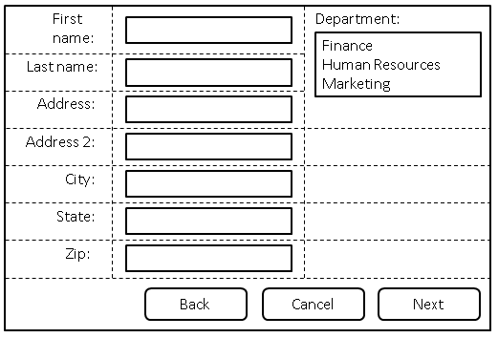

style type="text/css">
form {
display: grid;
/* Define three columns, all content-sized,
and name the corresponding lines. */
grid-template-columns: [labels] auto [controls] auto [oversized] auto;
grid-auto-flow: row dense;
}
form > label {
/* Place all labels in the "labels" column and
automatically find the next available row. */
grid-column: labels;
grid-row: auto;
}
form > input, form > select {
/* Place all controls in the "controls" column and
automatically find the next available row. */
grid-column: controls;
grid-row: auto;
}

#department-block {
/* Auto place this item in the "oversized" column
in the first row where an area that spans three rows
won’t overlap other explicitly placed items or areas
or any items automatically placed prior to this area. */
grid-column: oversized;
grid-row: span 3;
}

/* Place all the buttons of the form
in the explicitly defined grid area. */
#buttons {
grid-row: auto;

/* Ensure the button area spans the entire grid element
in the inline axis. */
grid-column: 1 / -1;
text-align: end;
}
</style>
<form>
<label for="firstname">First name:</label>
<input type="text" id="firstname" name="firstname" />
<label for="lastname">Last name:</label>
<input type="text" id="lastname" name="lastname" />
<label for="address">Address:</label>
<input type="text" id="address" name="address" />
<label for="address2">Address 2:</label>
<input type="text" id="address2" name="address2" />
<label for="city">City:</label>
<input type="text" id="city" name="city" />
<label for="state">State:</label>
<select type="text" id="state" name="state">
<option value="WA">Washington</option>
</select>
<label for="zip">Zip:</label>
<input type="text" id="zip" name="zip" />

<div id="department-block">
<label for="department">Department:</label>
<select id="department" name="department" multiple>
<option value="finance">Finance</option>
<option value="humanresources">Human Resources</option>
<option value="marketing">Marketing</option>
</select>
</div>

<div id="buttons">
<button id="cancel">Cancel</button>
<button id="back">Back</button>
<button id="next">Next</button>
</div>
</form>

The grid-column property specifies a grid item's size and location in a grid layout, and is a shorthand property for the following properties:
grid-column: grid-column-start / grid-column-end;
Value | Description
grid-column-start | Specifies on which column to start displaying the item.
grid-column-end | Specifies on which column-line to stop displaying the item, or how many columns to span.

Grid Definition Shorthand: the grid property

Name: | grid
Value: | <'grid-template'> | <'grid-template-rows'> / [ auto-flow && dense? ] <'grid-auto-columns'>? | [ auto-flow && dense? ] <'grid-auto-rows'>? / <'grid-template-columns'>
Initial: | none
Applies to: | grid containers
Inherited: | see individual properties
Percentages: | see individual properties
Computed value: | see individual properties
Animation type: | see individual properties
Canonical order: | per grammar

The grid property is a shorthand that sets all of the explicit grid properties (grid-template-rows, grid-template-columns, and grid-template-areas), and all the implicit grid properties (grid-auto-rows, grid-auto-columns, and grid-auto-flow), in a single declaration. (It does not reset the gutter properties.) Its syntax matches grid-template, plus an additional syntax form for defining auto-flow grids:

<'grid-template-rows'> / [ auto-flow && dense? ] <'grid-auto-columns'>?
[ auto-flow && dense? ] <'grid-auto-rows'>? / <'grid-template-columns'>
Sets up auto-flow, by setting the tracks in one axis explicitly (setting either grid-template-rows or grid-template-columns as specified, and setting the other to none), and specifying how to auto-repeat the tracks in the other axis (setting either grid-auto-rows or grid-auto-columns as specified, and setting the other to auto). grid-auto-flow is also set to either row or column accordingly, with dense if it’s specified.
All other grid sub-properties are reset to their initial values.

In addition to accepting the grid-template shorthand syntax for setting up the explicit grid, the grid shorthand can also easily set up parameters for an auto-formatted grid. For example, grid: auto-flow 1fr / 100px; is equivalent to
grid-template: none / 100px;
grid-auto-flow: row;
grid-auto-rows: 1fr;
grid-auto-columns: auto;
Similarly, grid: none / auto-flow 1fr is equivalent to
grid-template: none;
grid-auto-flow: column;
grid-auto-rows: auto;
grid-auto-columns: 1fr;

Placing Grid Items
Every grid item is associated with a grid area, a rectangular set of adjacent grid cells that the grid item occupies. This grid area defines the containing block for the grid item within which the self-alignment properties (justify-self and align-self) determine their actual position. The cells that a grid item occupies also influence the sizing of the grid’s rows and columns.

The location of a grid item’s grid area within the grid is defined by its placement, which consists of a grid position and a grid span:

grid position
The grid item’s location in the grid in each axis. A grid position can be either definite (explicitly specified) or automatic (determined by auto-placement).
grid span
How many grid tracks the grid item occupies in each axis.

The grid-placement properties—the longhands grid-row-start, grid-row-end, grid-column-start, grid-column-end, and their shorthands grid-row, grid-column, and grid-area—allow the author to specify a grid item’s placement by providing any (or none) of the following six pieces of information:

 | Row | Column
Start | row-start line | column-start line
End | row-end line | column-end line
Span | row span | column span

A definite value for any two of Start, End, and Span in a given dimension implies a definite value for the third.

The following table summarizes the conditions under which a grid position or span is definite or automatic:

 | Position | Span
Definite | At least one specified line | Explicit, implicit, or defaulted span.
Automatic | No lines explicitly specified | N/A

Named Areas
An item can be placed into a named grid area (such as those produced by the template in grid-template-areas) by specifying the area’s name in grid-area:
article {
grid-area: main;
/* Places item into the named area "main". */
}
An item can also be partially aligned with a named grid area, with other edges aligned to some other line:
.one {
grid-row-start: main;
/* Align the row-start edge to the start edge of the "main" named area. */
}

Numeric Indexes and Spans
Grid items can be positioned and sized by number, which is particularly helpful for script-driven layouts:
.two {
grid-row: 2; /* Place item in the second row. */
grid-column: 3; /* Place item in the third column. */
/* Equivalent to grid-area: 2 / 3; */
}
By default, a grid item has a span of 1. Different spans can be given explicitly:
.three {
grid-row: 2 / span 5;
/* Starts in the 2nd row,
spans 5 rows down (ending in the 7th row). */
}
.four {
grid-row: span 5 / 7;
/* Ends in the 7th row,
spans 5 rows up (starting in the 2nd row). */
}
Named Lines and Spans
Instead of counting lines by number, lines can be referenced by their line name:
.five {
grid-column: first / middle;
/* Span from line "first" to line "middle". */
}

if a named grid area has the same name as a line name, the placement algorithm will prefer to use named grid area’s lines instead.
If there are multiple lines of the same name, they effectively establish a named set of grid lines, which can be exclusively indexed by filtering the placement by name:
.six {
grid-row: text 5 / text 7;
/* Span between the 5th and 7th lines named "text". */
grid-row: text 5 / span text 2;
/* Same as above - start at the 5th line named "text",
then span across two more "text" lines, to the 7th. */
}
Auto Placement
A grid item can be automatically placed into the next available empty grid cell, growing the grid if there’s no space left.

.eight {
grid-area: auto; /* Initial value */
}
This can be used, for example, to list a number of sale items on a catalog site in a grid pattern.
Auto-placement can be combined with an explicit span, if the item should take up more than one cell:
.nine {
grid-area: span 2 / span 3;
/* Auto-placed item, covering two rows and three columns. */
}
Whether the auto-placement algorithm searches across and adds rows, or searches across and adds columns, is controlled by the grid-auto-flow property.
By default, the auto-placement algorithm looks linearly through the grid without backtracking; if it has to skip some empty spaces to place a larger item, it will not return to fill those spaces. To change this behavior, specify the dense keyword in grid-auto-flow.

Grid Item Placement vs. Source Order
“With great power comes great responsibility.”

The abilities of the grid-placement properties allow content to be freely arranged and reordered within the grid, such that the visual presentation can be largely disjoint from the underlying document source order. These abilities allow the author great freedom in tailoring the rendering to different devices and modes of presentation e.g. using media queries. However they are not a substitute for correct source ordering.

Correct source order is important for speech, for sequential navigation (such as keyboard navigation), and non-CSS UAs such as search engines, tactile browsers, etc. Grid placement only affects the visual presentation! This allows authors to optimize the document source for non-CSS/non-visual interaction modes, and use grid placement techniques to further manipulate the visual presentation so as to leave that source order intact.

Line-based Placement: the grid-row-start, grid-column-start, grid-row-end, and grid-column-end properties
Name: | grid-row-start, grid-column-start, grid-row-end, grid-column-end
Value: | <grid-line>
Initial: | auto
Applies to: | grid items and absolutely-positioned boxes whose containing block is a grid container
Inherited: | no
Percentages: | n/a
Computed value: | specified keyword, identifier, and/or integer
Canonical order: | per grammar
grid-row-start  Animation type: | discrete

<grid-line> =
auto |
<custom-ident> |
[ <integer> && <custom-ident>? ] |
[ span && [ <integer> || <custom-ident> ] ]
The grid-row-start, grid-column-start, grid-row-end, and grid-column-end properties determine a grid item’s size and location within the grid by contributing a line, a span, or nothing (automatic) to its grid placement, thereby specifying the inline-start, block-start, inline-end, and block-end edges of its grid area.

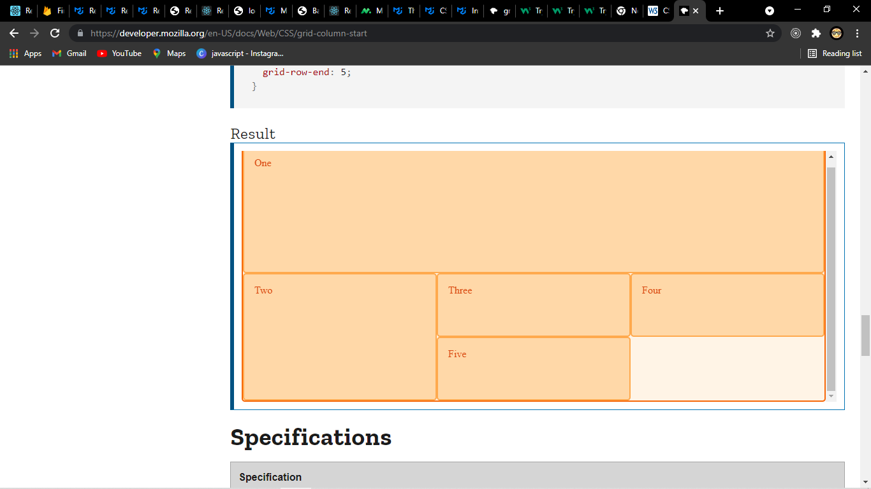
<div class="wrapper">
<div class="box1">One</div>
<div class="box2">Two</div>
<div class="box3">Three</div>
<div class="box4">Four</div>
<div class="box5">Five</div>
</div>
.wrapper {
display: grid;
grid-template-columns: repeat(3, 1fr);
grid-auto-rows: 100px;
}
.box1 {
grid-column-start: 1;
grid-column-end: 4;
grid-row-start: 1;
grid-row-end: 3;
}
.box2 {
grid-column-start: 1;
grid-row-start: 3;
grid-row-end: 5;
}

if there is a grid line whose line name is <custom-ident>-start (for grid-*-start) / <custom-ident>-end (for grid-*-end), contributes the first such line to the grid item’s placement.
Named grid areas automatically generate implicitly-assigned line names of this form, so specifying grid-row-start: foo will choose the start edge of that named grid area (unless another line named foo-start was explicitly specified before it).
Otherwise, treat this as if the integer 1 had been specified along with the <custom-ident>.

<integer> && <custom-ident>
Contributes the Nth grid line to the grid item’s placement. If a negative integer is given, it instead counts in reverse, starting from the end edge of the explicit grid.
If a name is given as a <custom-ident>, only lines with that name are counted. If not enough lines with that name exist, all implicit grid lines are assumed to have that name for the purpose of finding this position.
An <integer> value of zero makes the declaration invalid.

span && [ <integer> || <custom-ident> ]
Contributes a grid span to the grid item’s placement such that the corresponding edge of the grid item’s grid area is N lines from its opposite edge in the corresponding direction.
For example, grid-column-end: span 2 indicates the second grid line in the endward direction from the grid-column-start line.
If a name is given as a <custom-ident>, only lines with that name are counted. If not enough lines with that name exist, all implicit grid lines on the side of the explicit grid corresponding to the search direction are assumed to have that name for the purpose of counting this span.

Grid Placement Conflict Handling
If the placement for a grid item contains two lines, and the start line is further end-ward than the end line, swap the two lines.
If the start line is equal to the end line, remove the end line.

If the placement contains two spans, remove the one contributed by the end grid-placement property.

If the placement contains only a span for a named line, replace it with a span of 1.

Placement Shorthands: the grid-column, grid-row, and grid-area properties
Name: | grid-row, grid-column
Value: | <grid-line> [ / <grid-line> ]?
Initial: | auto
Applies to: | grid items and absolutely-positioned boxes whose containing block is a grid container
Inherited: | no
Percentages: | N/A
Computed value: | see individual properties
Animation type: | discrete
Canonical order: | per grammar
The grid-row and grid-column properties are shorthands for grid-row-start/grid-row-end and grid-column-start/grid-column-end, respectively.
If two <grid-line> values are specified, the grid-row-start/grid-column-start longhand is set to the value before the slash, and the grid-row-end/grid-column-end longhand is set to the value after the slash.

When the second value is omitted, if the first value is a <custom-ident>, the grid-row-end/grid-column-end longhand is also set to that <custom-ident>; otherwise, it is set to auto.

Name: | grid-area
Value: | <grid-line> [ / <grid-line> ]{0,3}
Initial: | auto
Applies to: | grid items and absolutely-positioned boxes whose containing block is a grid container
Inherited: | no
Percentages: | N/A
Computed value: | see individual properties
Animation type: | discrete
Canonical order: | per grammar

The grid-area property is a shorthand for grid-row-start, grid-column-start, grid-row-end and grid-column-end.

If four <grid-line> values are specified, grid-row-start is set to the first value, grid-column-start is set to the second value, grid-row-end is set to the third value, and grid-column-end is set to the fourth value.

When grid-column-end is omitted, if grid-column-start is a <custom-ident>, grid-column-end is set to that <custom-ident>; otherwise, it is set to auto.

When grid-row-end is omitted, if grid-row-start is a <custom-ident>, grid-row-end is set to that <custom-ident>; otherwise, it is set to auto.

When grid-column-start is omitted, if grid-row-start is a <custom-ident>, all four longhands are set to that value. Otherwise, it is set to auto.

Grid Item Placement Algorithm
grid item placement algorithm resolves automatic positions of grid items into definite positions, ensuring that every grid item has a well-defined grid area to lay out into. (Grid spans need no special resolution; if they’re not explicitly specified, they default to 1.)
This algorithm can result in the creation of new rows or columns in the implicit grid, if there is no room in the explicit grid to place an auto-positioned grid item.

Every grid cell (in both the explicit and implicit grids) can be occupied or unoccupied. A cell is occupied if it’s covered by the grid area of a grid item with a definite grid position; otherwise, the cell is unoccupied. A cell’s occupied/unoccupied status can change during this algorithm.

To aid in clarity, this algorithm is written with the assumption that grid-auto-flow has row specified. If it is instead set to column, swap all mentions of rows and columns, inline and block, etc. in this algorithm.

- Generate anonymous grid items
Anonymous grid items are always auto-placed,

- Position anything that’s not auto-positioned.

- Process the items locked to a given row.
For each grid item with a definite row position (that is, the grid-row-start and grid-row-end properties define a definite grid position),
“sparse” packing (default behavior)
Set the column-start line of its placement to the earliest (smallest positive index) line index that ensures this item’s grid area will not overlap any occupied grid cells and that is past any grid items previously placed in this row by this step.

“dense” packing (dense specified)
Set the column-start line of its placement to the earliest (smallest positive index) line index that ensures this item’s grid area will not overlap any occupied grid cells.

- Determine the columns in the implicit grid.
Create columns in the implicit grid:
Start with the columns from the explicit grid.

Among all the items with a definite column position (explicitly positioned items, items positioned in the previous step, and items not yet positioned but with a definite column) add columns to the beginning and end of the implicit grid as necessary to accommodate those items.

If the largest column span amon+g all the items without a definite column position is larger than the width of the implicit grid, add columns to the end of the implicit grid to accommodate that column span.
For example, in the following style fragment:
#grid {
display: grid;
grid-template-columns: repeat(5, 100px);
grid-auto-flow: row;
}
#grid-item {
grid-column: 4 / span 3;
}
The number of columns needed is 6. The explicit grid provides 5 columns (from grid-template-columns) with lines number 1 through 6, but #grid-item’s column position means it ends on line 7, which requires an additional column added to the end of the implicit grid.

- Position the remaining grid items.
The auto-placement cursor defines the current “insertion point” in the grid, specified as a pair of row and column grid lines. Initially the auto-placement cursor is set to the start-most row and column lines in the implicit grid.
The grid-auto-flow value in use determines how to position the items:

“sparse” packing (default behavior)
For each grid item that hasn’t been positioned by the previous steps,

If the item has a definite column position:
-Set the column position of the cursor to the grid item’s column-start line. If this is less than the previous column position of the cursor, increment the row position by 1.
-Increment the cursor’s row position until a value is found where the grid item does not overlap any occupied grid cells (creating new rows in the implicit grid as necessary).
-Set the item’s row-start line to the cursor’s row position, and set the item’s row-end line according to its span from that position.

If the item has an automatic grid position in both axes:
If the item has an automatic grid position in both axes:
-Increment the column position of the auto-placement cursor until either this item’s grid area does not overlap any occupied grid cells, or the cursor’s column position, plus the item’s column span, overflow the number of columns in the implicit grid, as determined earlier in this algorithm.
-If a non-overlapping position was found in the previous step, set the item’s row-start and column-start lines to the cursor’s position. Otherwise, increment the auto-placement cursor’s row position (creating new rows in the implicit grid as necessary), set its column position to the start-most column line in the implicit grid, and return to the previous step.

“dense” packing (dense specified)
For each grid item that hasn’t been positioned by the previous steps, in order-modified document order:

If the item has a definite column position:
-Set the row position of the cursor to the start-most row line in the implicit grid. Set the column position of the cursor to the grid item’s column-start line.
-Increment the auto-placement cursor’s row position until a value is found where the grid item does not overlap any occupied grid cells (creating new rows in the implicit grid as necessary).
-Set the item’s row-start line index to the cursor’s row position. (Implicitly setting the item’s row-end line according to its span, as well.)

If the item has an automatic grid position in both axes:
-Set the cursor’s row and column positions to start-most row and column lines in the implicit grid.
-Increment the column position of the auto-placement cursor until either this item’s grid area does not overlap any occupied grid cells, or the cursor’s column position, plus the item’s column span, overflow the number of columns
in the implicit grid, as determined earlier in this algorithm.
-If a non-overlapping position was found in the previous step, set the item’s row-start and column-start lines to the cursor’s position. Otherwise, increment the auto-placement cursor’s row position (creating new rows in the
implicit grid as necessary), reset its column position to the start-most column line in the implicit grid, and return to the previous step.

Absolute Positioning

With a Grid Container as Containing Block
If an absolutely positioned element’s containing block is generated by a grid container, the containing block corresponds to the grid area determined by its grid-placement properties. The offset properties (top/right/bottom/left) then indicate offsets inwards from the corresponding edges of this containing block, as normal.
While absolutely-positioning an element to a grid container does allow it to align to that container’s grid lines, such elements do not take up space or otherwise participate in the layout of the grid.

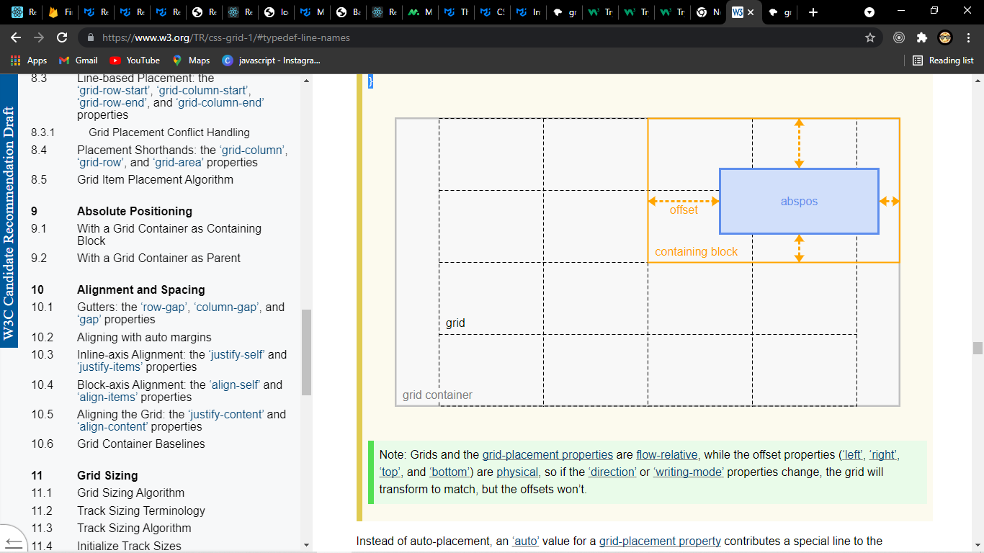
.grid {
grid: 1fr 1fr 1fr 1fr / 10rem 10rem 10rem 10rem;
/* 4 equal-height rows filling the grid container,
4 columns of 10rem each */
justify-content: center;
/* center the grid horizontally within the grid container */
position: relative;
/* Establish abspos containing block */
}
.abspos {
grid-row-start: 1; /* 1st grid row line = top of grid container */
grid-row-end: span 2; /* 3rd grid row line */
grid-column-start: 3; /* 3rd grid col line */
grid-column-end: auto; /* right padding edge */
/* Containing block covers the top right quadrant of the grid container */
position: absolute;
top: 70px;
bottom: 40px;
left: 100px;
right: 30px;
}
Absolute positioning occurs after layout of the grid and its in-flow contents, and does not contribute to the sizing of any grid tracks or affect the size/configuration of the grid in any way. If a grid-placement property refers to a non-existent line either by explicitly specifying such a line or by spanning outside of the existing implicit grid, it is instead treated as specifying auto (instead of creating new implicit grid lines).

containing block
A rectangle that forms the basis of sizing and positioning for the boxes associated with it. Notably, a containing block is not a box (it is a rectangle), however it is often derived from the dimensions of a box. Each box is given a position with respect to its containing block, but it is not confined by this containing block; it can overflow. The phrase “a box’s containing block” means “the containing block in which the box lives,” not the one it generates.
In general, the edges of a box act as the containing block for descendant boxes; we say that a box “establishes” the containing block for its descendants. If properties of a containing block are referenced, they reference the values on the box that generated the containing block. (For the initial containing block, values are taken from the root element unless otherwise specified.)

With a Grid Container as Parent
An absolutely-positioned child of a grid container is out-of-flow and not a grid item, and so does not affect the placement of other items or the sizing of the grid.

The static position [CSS2] of an absolutely-positioned child of a grid container is determined as if it were the sole grid item in a grid area whose edges coincide with the content edges of the grid container. However, if the grid container parent is also the generator of the absolutely positioned element’s containing block, instead use the grid area determined in § 9.1 With a Grid Container as Containing Block.
Note that this position is affected by the values of justify-self and align-self on the child, and that, as in most other layout models, the absolutely-positioned child has no effect on the size of the containing block or layout of its contents.

Alignment and Spacing

After a grid container’s grid tracks have been sized, and the dimensions of all grid items are finalized, grid items can be aligned within their grid areas.

The margin properties can be used to align items in a manner similar to what margins can do in block layout.
By default, grid items stretch to fill their grid area. However, if justify-self or align-self compute to a value other than stretch or margins are auto, grid items will auto-size to fit their contents.

Gutters: the row-gap, column-gap, and gap properties
The row-gap and column-gap properties (and their gap shorthand), when specified on a grid container, define the gutters between grid rows and grid columns.
The effect of these properties is as though the affected grid lines acquired thickness:
he grid track between two grid lines is the space between the gutters that represent them.
For the purpose of track sizing, each gutter is treated as an extra, empty, fixed-size track of the specified size, which is spanned by any grid items that span across its corresponding grid line.
Additional spacing may be added between tracks due to justify-content/align-content

If a grid is fragmented between tracks, the gutter spacing between those tracks must be suppressed.

Gutters only appear between tracks of the implicit grid; there is no gutter before the first track or after the last track.

When a collapsed track’s gutters collapse, they coincide exactly—the two gutters overlap so that their start and end edges coincide. If one side of a collapsed track does not have a gutter (e.g. if it is the first or last track of the implicit grid), then collapsing its gutters results in no gutter on either “side” of the collapsed track.

Aligning with auto margins
Auto margins on grid items have an effect very similar to auto margins in block flow:

-During calculations of grid track sizes, auto margins are treated as 0.
-auto margins absorb positive free space prior to alignment
-Overflowing elements ignore their auto margins and overflow

Inline-axis Alignment: the justify-self and justify-items properties
Grid items can be aligned in the inline dimension by using the justify-self property on the grid item or justify-items property on the grid container

Block-axis Alignment: the align-self and align-items properties
If the grid’s outer edges do not correspond to the grid container’s content edges (for example, if no columns are flex-sized), the grid tracks are aligned within the content box according to the justify-content and align-content properties on the grid container. "content" set are there because: "Sometimes the total size of your grid might be less than the size of its grid container" as it depends on the way we define.
.grid {
display: grid;
grid: 12rem 12rem 12rem 12rem / 10rem 10rem 10rem 10rem;
justify-content: end;
align-content: center;
}
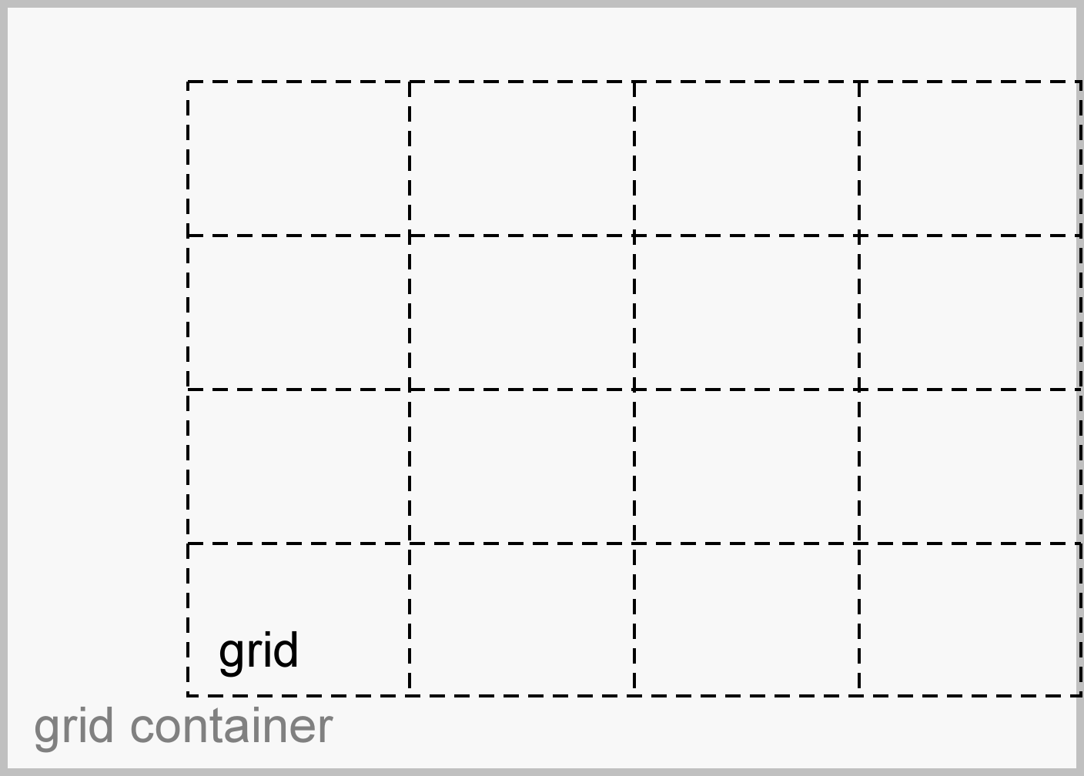
If there are no grid tracks (the explicit grid is empty, and no tracks were created in the implicit grid), the sole grid line in each axis is aligned with the start edge of the grid container.
Note that certain values of justify-content and align-content can cause the tracks to be spaced apart (space-around, space-between, space-evenly) or to be resized (stretch). If the grid is fragmented between tracks, any such additional spacing between those tracks must be suppressed.

For example, in the following grid, the spanning item’s grid area is increased to accommodate the extra space assigned to the gutters due to alignment:
.wrapper {
display: grid;
/* 3-row / 4-column grid container */
grid: repeat(3, auto) / repeat(4, auto);
gap: 10px;
align-content: space-around;
justify-content: space-between;
}
.item1 { grid-column: 1 / 5; }
.item2 { grid-column: 1 / 3; grid-row: 2 / 4; }
.item3 { grid-column: 3 / 5; }
/* last two items auto-place into the last two grid cells */
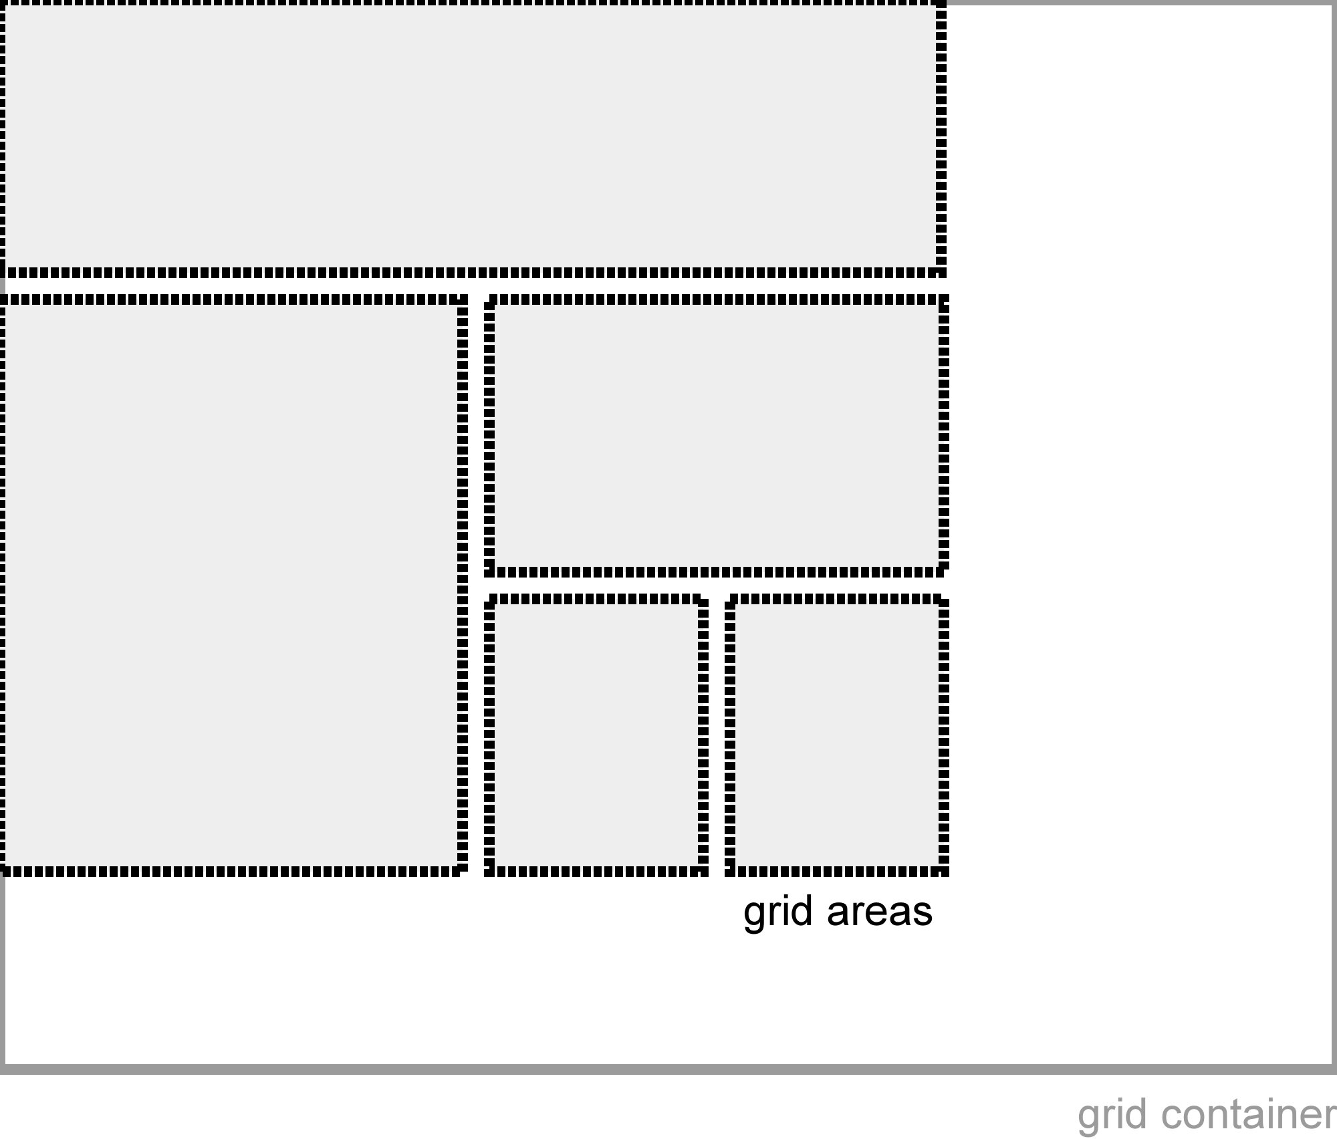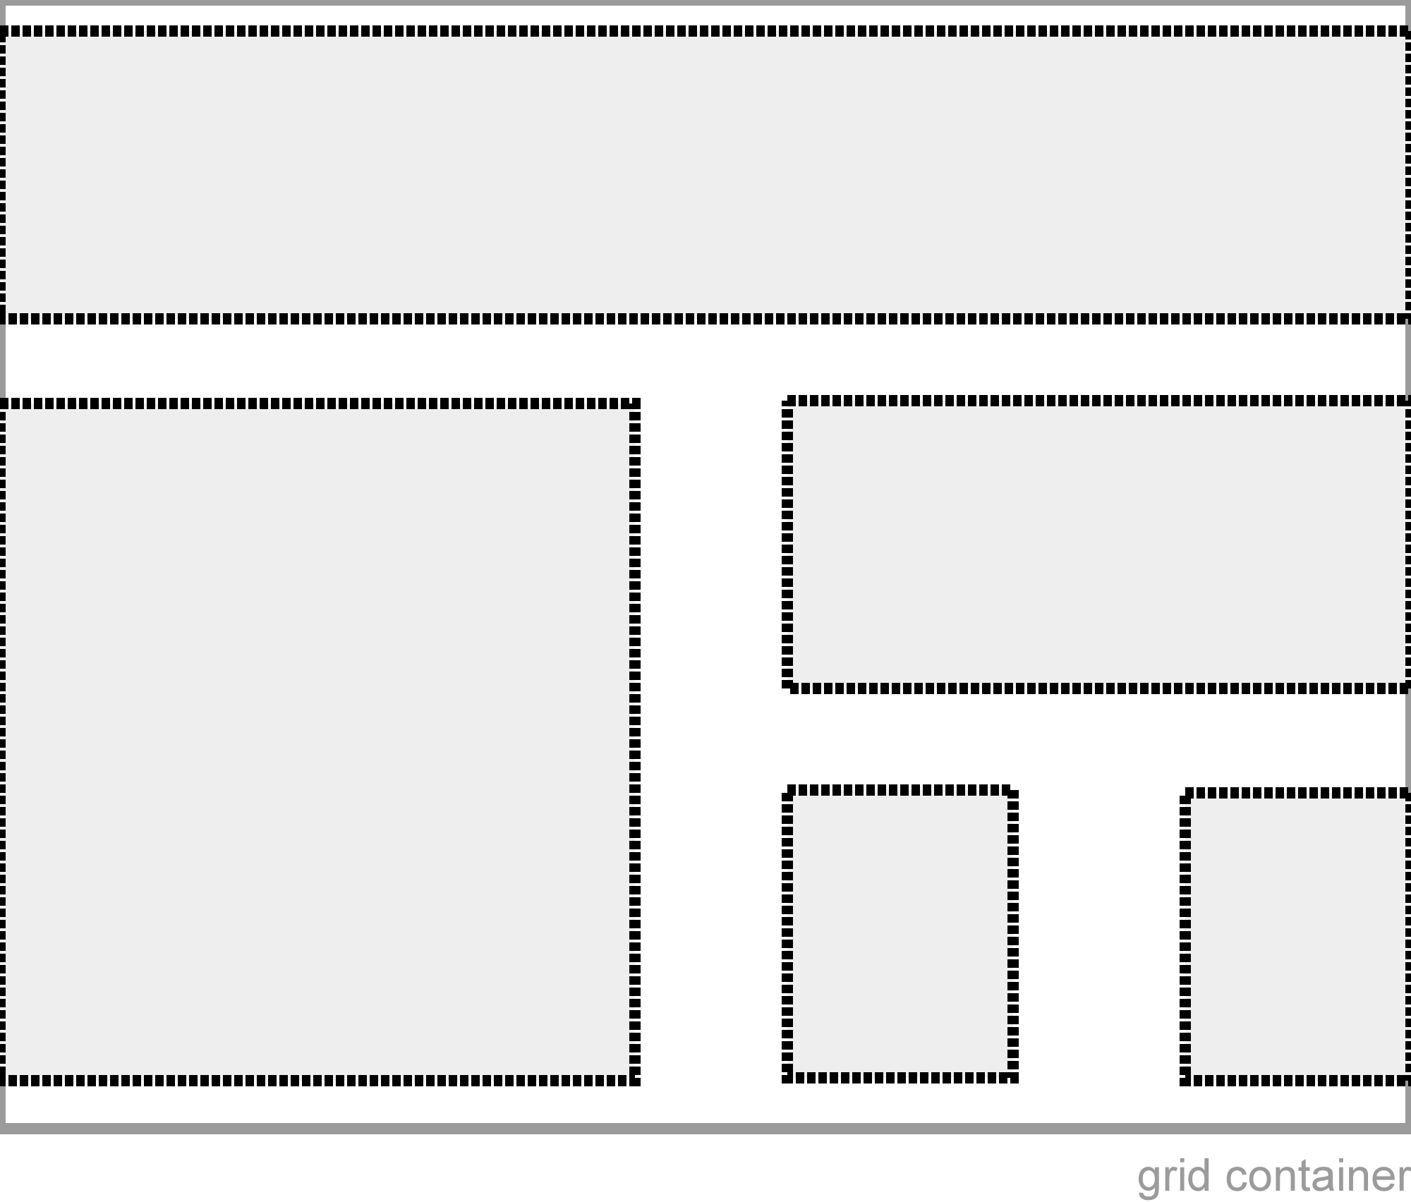
Before Alignment After alignment

Note that alignment (unlike gap spacing) happens after the grid tracks are sized, so if the track sizes are determined by the contents of the spanned item, it will gain excess space in the alignment stage to accommodate the alignment spacing.

Grid Container Baselines

The first (last) baselines of a grid container are determined as follows:

Find the first (last) row of the grid container containing at least one grid item.
If any of the grid items intersecting this row participate in baseline alignment in that row, the grid container’s baseline set is generated from the shared alignment baseline of those grid items.

Otherwise, the grid container’s first (last) baseline set is generated from the alignment baseline of the first (last) grid item in row-major grid order (according to the writing mode of the grid container). If the grid item has no alignment baseline in the grid’s inline axis, then one is first synthesized from its border edges.

If the grid container does not contain any grid items, the grid container has no first (last) baseline set, and one is synthesized if needed according to the rules of its alignment context. Exit from this algorithm.
Grid-modified document order (grid order) is the order in which grid items are encountered when traversing the grid’s grid cells. If two items are encountered at the same time, they are taken in order-modified document order.

When calculating the baseline according to the above rules, if the box contributing a baseline has an overflow value that allows scrolling, the box must be treated as being in its initial scroll position for the purpose of determining its baseline.

When determining the baseline of a table cell, a grid container provides a baseline just as a line box or table-row does. [CSS2]

Grid Sizing
grid sizing algorithm determines the size of all grid tracks and, by extension, the entire grid.

Each track has specified minimum and maximum sizing functions (which may be the same). Each sizing function is either:

A fixed sizing function (<length> or resolvable <percentage>).
An intrinsic sizing function (min-content, max-content, auto, fit-content()).
A flexible sizing function (<flex>).
The grid sizing algorithm defines how to resolve these sizing constraints into used track sizes.

